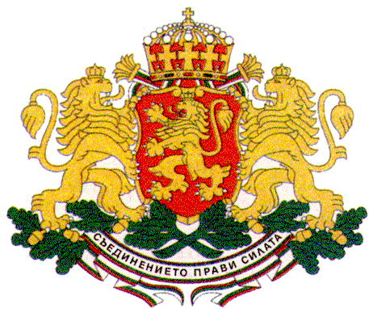 | PERMANENT MISSION OF THE REPUBLIC OF  BULGARIA  TO THE UNITED NATIONS
11 East 84th Street, New York, NY 10028, Tel: (212) 737 4790, Fax: (212) 472 9865, e-mail: bulgaria@un.int

Group of Friends of Children and SDGs
New York, 12 January 2017

The World’s Largest Lesson

H.E. Mr. Georgi Panayotov, Ambassador,
Permanent Representative of Bulgaria to the UN

The adoption of the 2030 Agenda for Sustainable Development is a historic achievement and a crucial step forward in the efforts of the international community towards creating a world where all people, and especially children, live in prosperity, peace and dignity.
During the negotiations Bulgaria has advocated strongly, including as a co-chair of the Group of Friends of Children and SDGs, for integrating children’s human rights in all aspects of development with the aim to put children at the heart of the new global framework. The 2030 Agenda is truly transformative as it was designed for the people envisaging children and youth as the real agents of change.
Since the adoption of the 2030 Agenda in September 2015 Bulgaria has been actively participating in the World’s Largest Lesson Global Initiative aimed at teaching children about the Sustainable Development Goals. The Ministry of Education and Science of Bulgaria has signed a partnership agreement with UNICEF Bulgaria to help the Government implement the World’s Largest Lesson. The Minister of Education has instructed all schools in Bulgaria to acquaint students with the SDGs. As a result, more than 40 000 students in over 1 500 schools have already learned about the SDGs, which was highlighted by the President of Bulgaria during his address to the General Assembly in September last year.
Bulgaria believes that this initiative, which has already mobilized more than 500 million girls and boys in over 160 countries can become a powerful movement to engage children in the joint effort to achieve the new goals by encouraging them to drive real change in their own lives. We are grateful to the Executive Director of UNICEF Mr. Anthony Lake and his team for this important initiative and to the President of the General Assembly H.E. Peter Thomson for embracing this topic as one of his main priorities.
Now, I would like to encourage other countries to also share their experience.

